Operating Systems Lab
Submitted by:Tuba Akbar Ali
enrollment id:f2024332024
submitted to:prof. Talha khalid

Task 1: Create folder
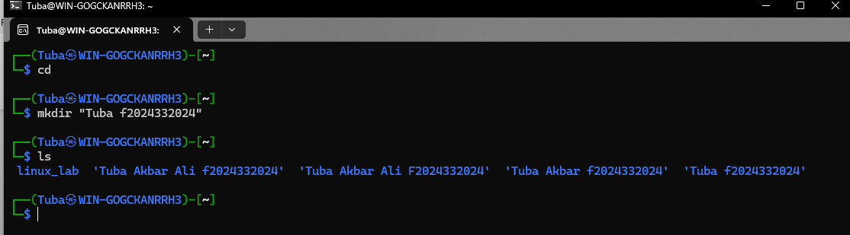

Task 2: Create sub -folders

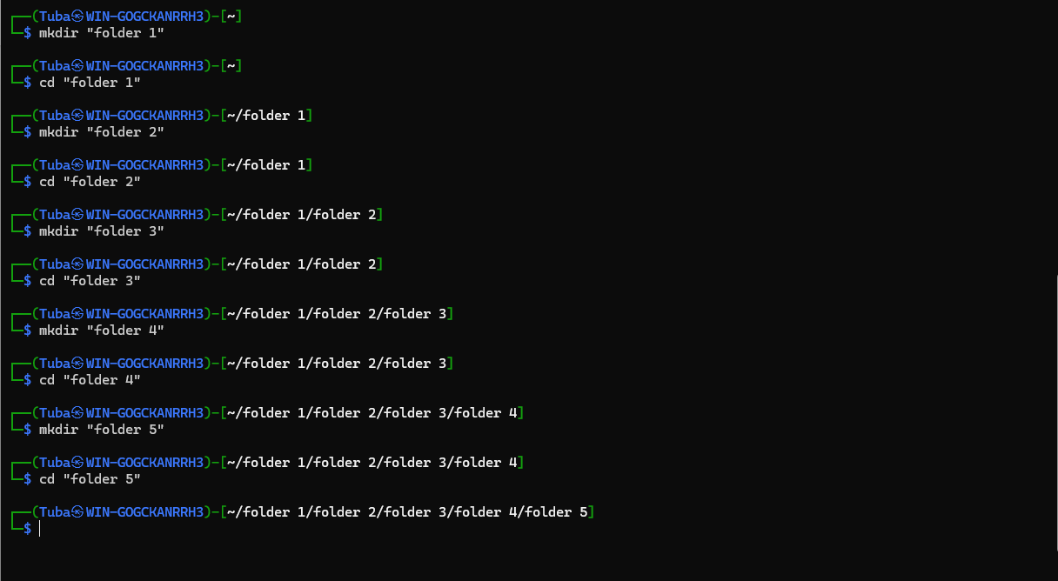

Task 3: Display Folder
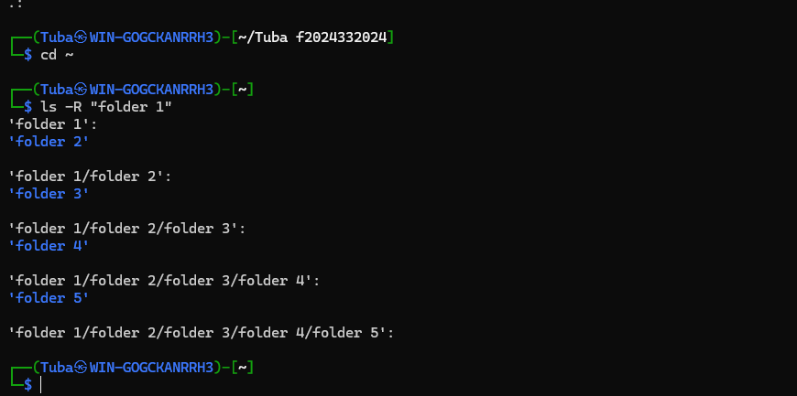
Task 4:Use nano to save intro

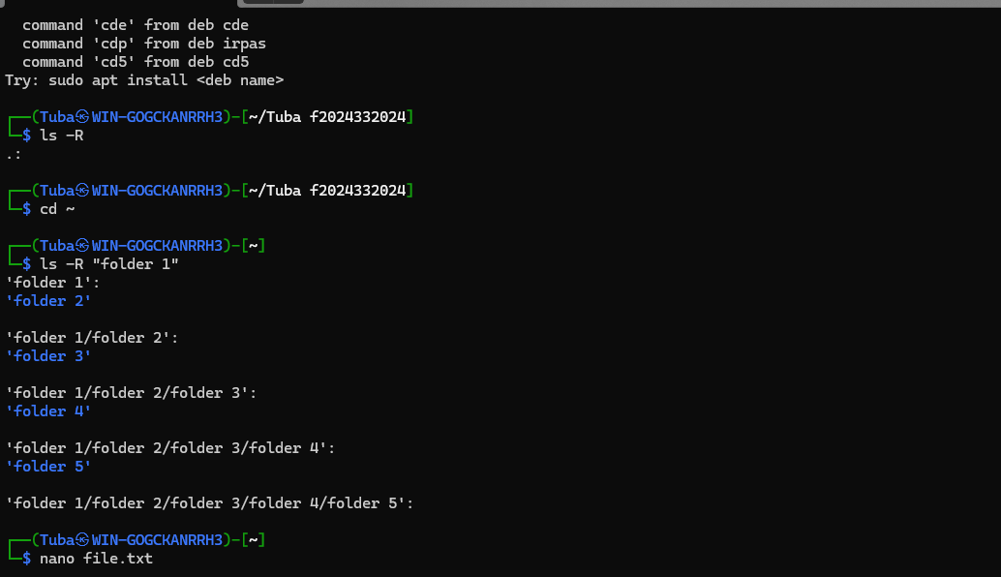

Task 5:Display the intro
